Requirement Document- AP

Prepared By : Swathi

Reviewed By : ALAN,GOKUL,VASAN

Proprietary Notice

The information contained in this document is of a proprietary nature. The disclosure, duplication, use in whole, or use in part, of the proposal for any purposes without the written permission of LogiWare is prohibited.

Account Payable – Check Register Screen

Given Layout Design:
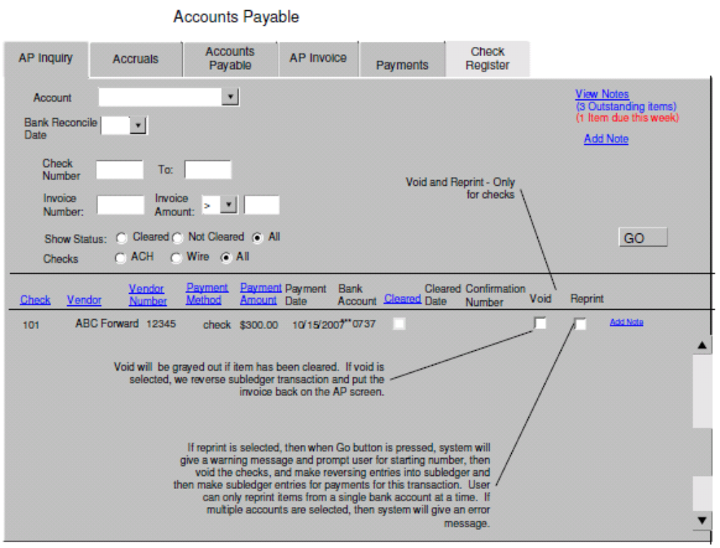
Clarification Required:
1.
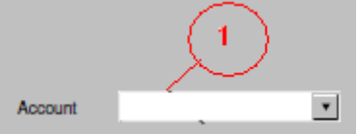

- What values should the account number fetch here and based on which status .Does it means to fetch the GL Account number? Need clear details..

2.
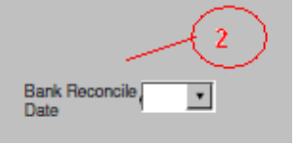
- Is this same as in Reconcile Screen ,that should have Date Range and Check Number Filter ?
Need Details.

3.
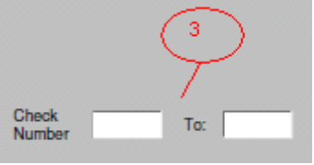
- What value should this 'To' field display? Is this the Customer Name? Need details.

4.
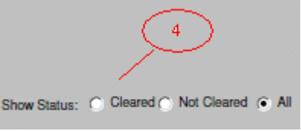
- What actions should be permitted for these statuses, when Cleared ,Not Cleared or All are selected. Are these statuses restricted to Account Name or Account Number specified in 'Account' field at the top of the screen or for all the customers having these statuses?
Need Details..

5.
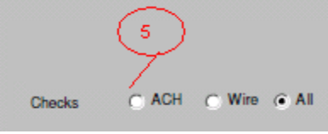
- What actions should be permitted for these checks, when ACH ,Wire or All are selected. Are these checks restricted to Account Name or Account Number specified in 'Account' field at the top of the screen or for all the customers with those statuses? Need Details..

6.
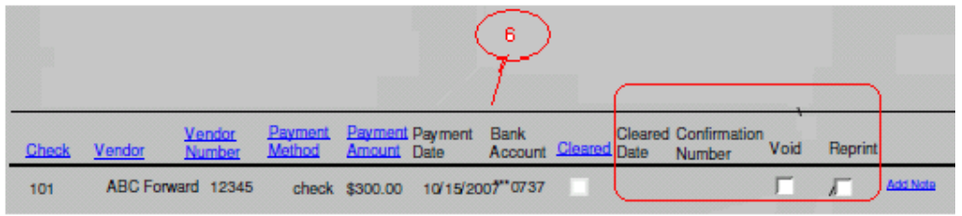
- This is the display format given when we search for a particular Account.
What values should be displayed for 'Cleared Date' and 'Confirmation Number' as in the screen shot.
- When 'Cleared' is checked ,its mentioned that 'Void ' will be grayed out and sub ledger transaction is reversed by putting invoice back into AP screen. Does this mean to change the status for that particular vendor.
Need more explanation on this.
- Reprint--> functionalities to be performed when this is selected is not clear.
- Print design should be provided.
Need more clear explanation for this.

7. Notes : Details needed.

